1. **Agenda**:
   1. Some of the important configuration when building Kafka Producer.
2. 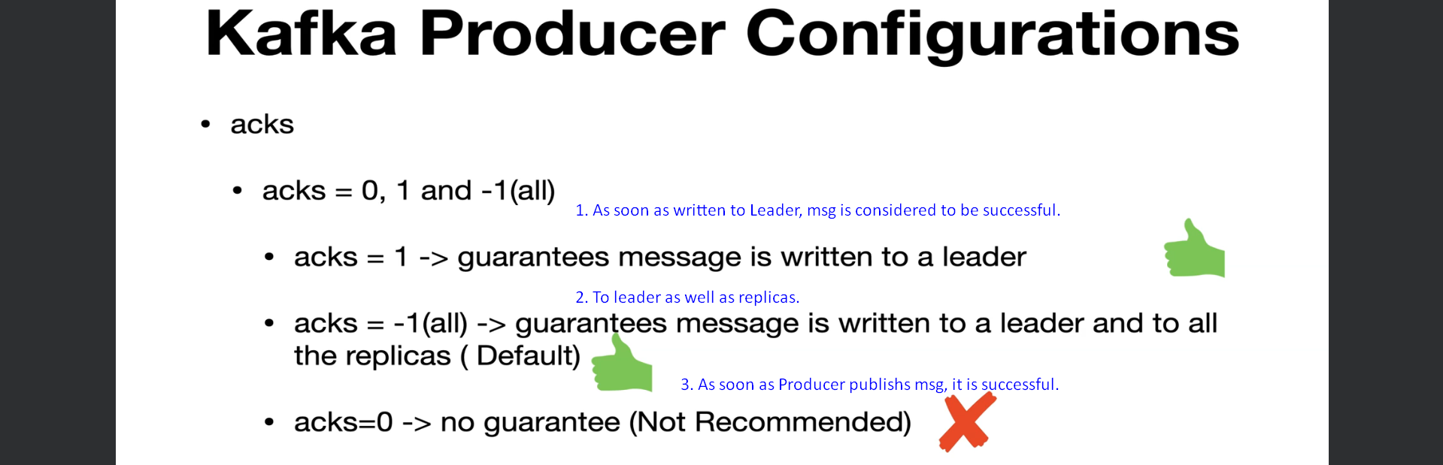
3. 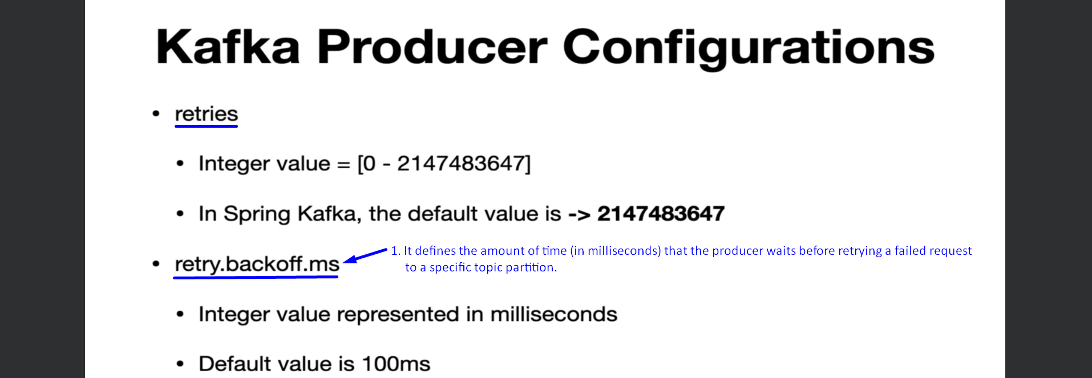
4. 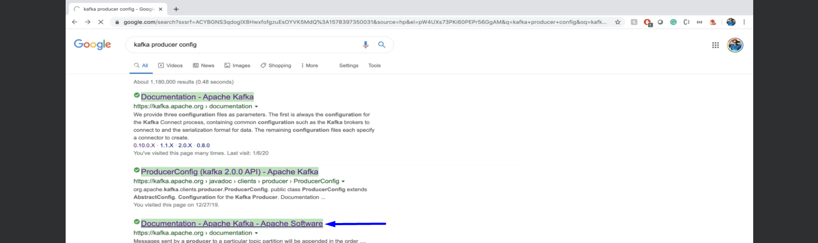
5. 